React Notes
- React is an external library that help us create website easier
- React has two main external libraries (react is design to be used in mobile and websites, so creators split them in two)
  - React: shared features used for both mobile and web applications
    - For mobile we typically load the React and ReactNative library
  - ReactDom: usually features specific for websites
    - For website we use React and ReactDom
HTML
Element
- <script> </script> we can write JavaScript code inside it
  - Or you create a file example react-basics.js
  - And inside of <script> you write <script src=”react-basics.js”></script>
  - It loads the js file
  - The script element can load anywhere on the internet. Unpkg.com/supersimpledev/external-library.js you then get the url in this is https://unpkg.com/supersimpledev@8.6.4/external-library.js
inside the script element we can do <script src=” https://unpkg.com/supersimpledev@8.6.4/external-library.js”></script>
  - This also know as external library that we can use that someone else wrote
- <!DOCTYPE html>
- <html>
- <head>
- <title>React Basics</title>
- </head>
- <body>
- <div class="js-container"></div>

- <script src="https://unpkg.com/supersimpledev@8.6.4/external-library.js"></script>

- <script src="https://unpkg.com/supersimpledev/react.js"></script>
- <script src="https://unpkg.com/supersimpledev/react-dom.js"></script>

- <script src="https://unpkg.com/supersimpledev/babel.js"></script>
- <script type="text/babel">
- const container = document.querySelector('.js-container');
- ReactDOM.createRoot(container).render('Welcome to SuperSimpleDev React Course');
- </script>
- </body>
- </html>
The few lines below allows to set up React
<script type="text/babel">
const container = document.querySelector('.js-container');
ReactDOM.createRoot(container).render('Welcome to SuperSimpleDev React Course');
</script>
- The document is an object that is called DOM (document object model) that somewhat combines html and JavaScript.
- This allows us to get html elements from the page and into the js and js also allows to modify elements in the page
HTML structure
- <!DOCTYPE html> tells the computer to use the modern version of HTML
- <html>
</html>
represents a website so all the code for the website should go into this element. Every website is split into 2 sections, the head and body sections
- <head>
- </head>
contains things that are not visible on the page
for example the element <title>React Basics</title> does not show on the page but rather outside of it, like the tab
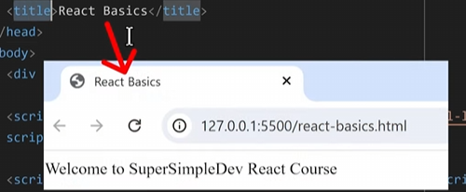
- <body></body> shows things that are going to shown on the page
for ex <div></div> will be shown on the page
NOTE: that when we use React we use normal JavaScript but rather JSX which is JavaScript XML; in JSX we can write HTML directly in our JavaScript code.
- However our web browser does not understand JSX so it needs to be translated to JS. To do that we use the Babel library to translate JSX to JS.
- To do this we must first load the Babel library and then <script type=></script> use script and give it an attribute example below
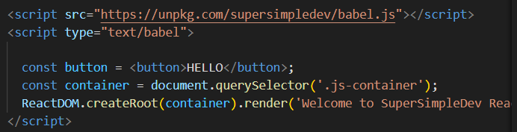
- The first line loads the Babel library
- 2nd line give the script an attribute of type and “text/babel” tells it that all the things inside the script body to be converted to JS; which is also an html element
- 3rd line creates button
Components
- For React a component is piece of a website
- 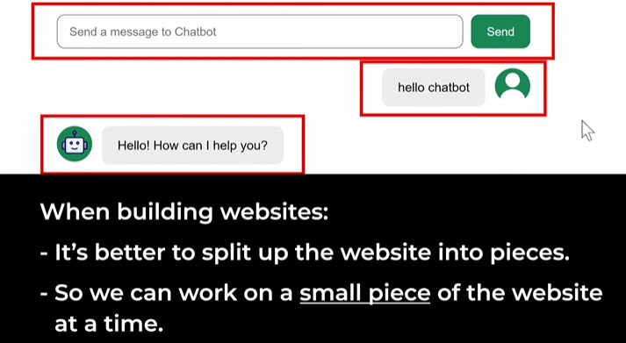
- You can create a component by creating a function a component has to start with Capital letter
The best practice is to use a component to create the website.
- As shown below we have a component called App() and is being displayed by ReactDOM
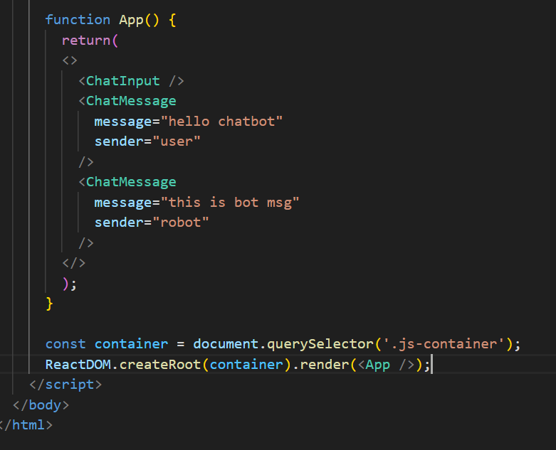
State, Event Handles
- An event handler let us interact with a function when clicked on

